1. Explain the purpose of the DataType attribute.

DataType specifies a data type that’s different from the database’s intrinsic data type.

1. Describe the relationship between the DataType attribute and HTML5.

Datatype emits an HTML5 data- attributes that HTML5 consumes though they don’t provide built in validation.

1. The DisplayFormat attribute can be used by itself without the DataType attribute, but what is the advantage of using DataType?

The advantage with using DataType is that the browser can enable HTML5 features and by default the browser will display the correct data format based on locale.

1. Do a screen print of the Student page showing the revision of the enrollment date field.

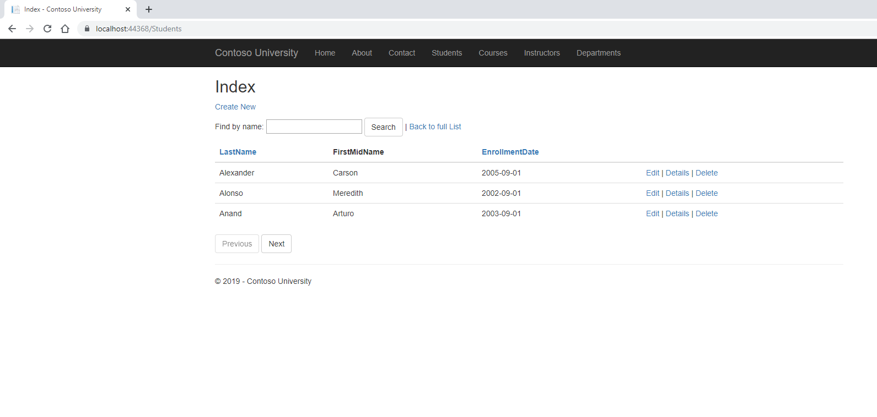

1. Do a screen print of the Create Student page demonstrating the editing capabilities of the StringLength and RegularExpression attributes applied to the first and last name fields.

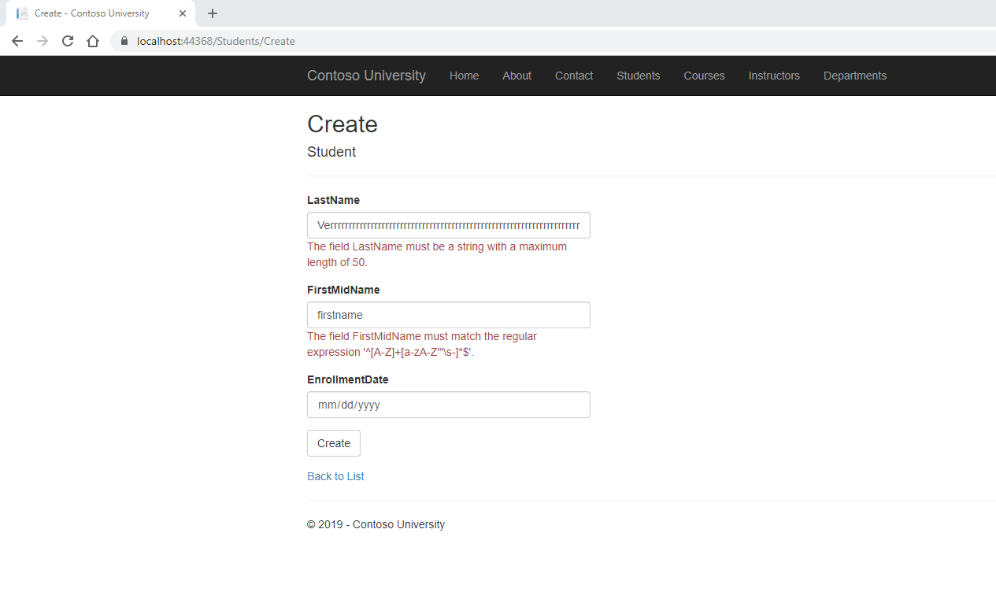

1. What attribute is used to change the model field name to a different name in the database?

Display

1. What must you remember to do when you change the model?

To update your data base to match that new model.

1. Do a screen print from SSOX showing the new table design after migrations.
2. When is the Required attribute not needed?

When the values are already unable to be set to null or have a minimum length.

1. Assuming a field is required, what’s an alternative to using the Required attribute?

You may add a Minimun length to the String length attribute.

1. In the case of a one-to-many relationship in the schema (student having more than one course, for example), how does entity framework handle it in code?

Through creating a matching HashSet<T> To the Collection<T>

1. When must the Key attribute be used?

When the property name is something other than ID or ClassNameID.

1. True or False: Entity Framework automatically creates foreign keys.

True

1. What is the code to override the default action of cascade delete for the Department/Instructor relationship?

modelBuilder.Entity<Department>()

.HasOne(d => d.Administrator)

.WithMany()

.OnDelete(DeleteBehavior.Restrict)

1. Briefly decribe the term FluentAPI.

A tool that allows you to string multiple methods together. This is used to replace attributes and replace EF Core configuration.

1. Use the migrations feature to seed the new database. Do a screen print of the new code that was added to do this.